Health Te Aroha Newsletter
To provide GP led primary health care services in a multidisciplinary setting with a commitment to excellence

byuo

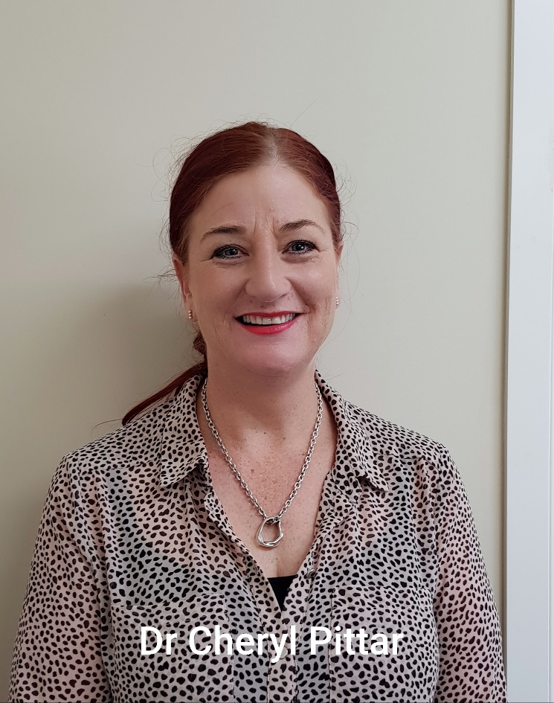
**Welcome to Dr Cheryl Pittar***
Cheryl was born and bred in Tauranga, and currently lives at Mount Maunganui; she will be with us two and a half days a week. She studied medicine at Auckland University, coincidently in the same graduate year as Dr Titterton when she attended. Outside of work she has a 19 year old son and enjoys running, competing in cross country challenges. We are delighted to have Cheryl on board and hope she enjoys her time here.
Health Te Aroha Pharmacy is closed.
Due to the difficulty in recruiting pharmacists in rural areas, this pharmacy is closed for the next 3 months.
In February 2020, Te Aroha Unichem will address the closure and hopefully will have the resources in place to reopen.
In the meantime, all prescriptions can be obtained from Unichem Te Aroha Pharmacy, 189 Whitaker St, Te Aroha 07 8849 517
We apologise for any inconvenience
ACC Claims
We have had a lot of enquiries regarding the way ACC is charged and subsidised
The following is an excerpt from the ACC website-
“If we cover your injury, we can contribute to part of your appointment to your health provider as set out by the ACC Cost of treatment regulations. You’ll need to pay for the rest. Check with your health provider for their fees.
If you have a Community Services Card or are a dependant (14 – 17 years of age) of a Community Service Card holder, you may get a lower- cost visit to your GP. Most GPs will also offer zero-fees for children under 14 years.”
For more information you can check out the full article at https://www.acc.co.nz/im-injured/what-to-do/
We are now offering free WiFi for the patients in the waiting room, just find “Health Te Aroha Guest” in your WiFi settings and accept the terms and conditions to get connected.
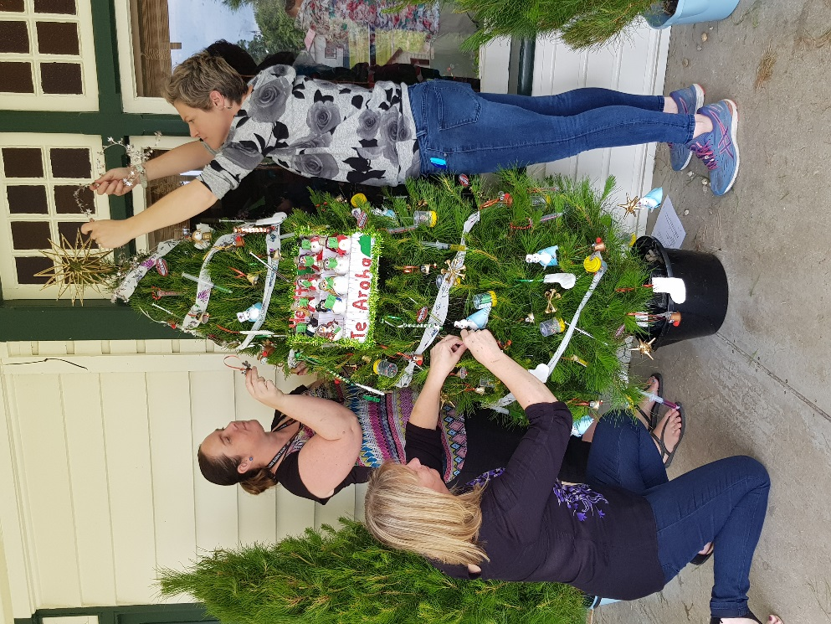
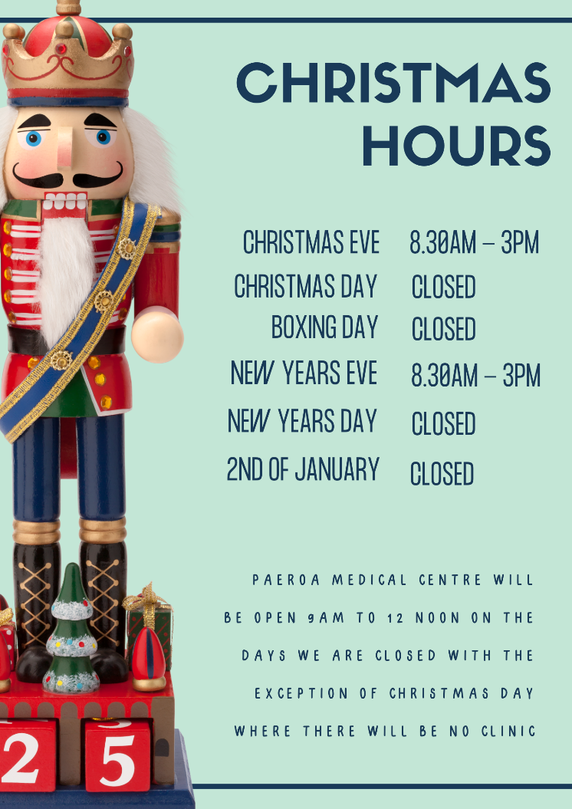
We had heaps of fun creating decorations for the first annual Community Christmas Tree Festival

