Health Te Aroha Newsletter
To provide GP led primary health care services in a multidisciplinary setting with a commitment to excellence

byuo

We are pleased to offer cheaper consultations for community service card (CSC) holders and their dependants.
It is now $18.50 for a *standard adults consultation or ACC related visit. In addition to this, consults for registered youths between the ages of 14 and 17 are $12.50 and under the age of 14 are free.
People, who receive the accommodation supplement or live in public housing, are automatically eligible for the CSC. If you think you may qualify for a CSC you can check eligibility and apply at www.workandincome.govt.nz/csc or call 0800 999 999
*Standard consult are 15 minutes long, please note for extended consults, casual, afterhours or special services a higher fee maybe incurred.
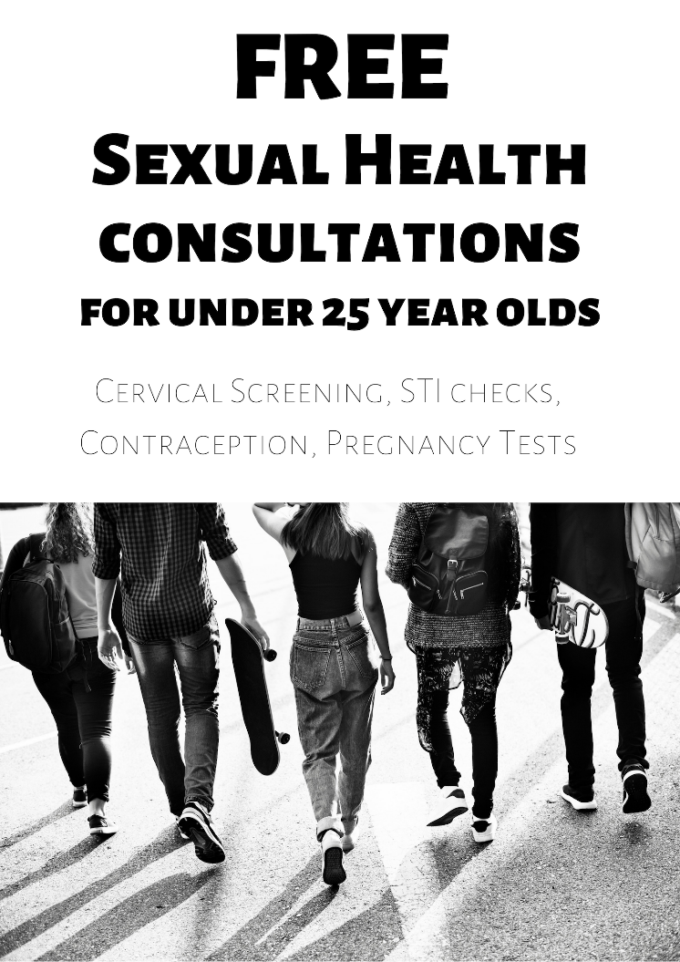
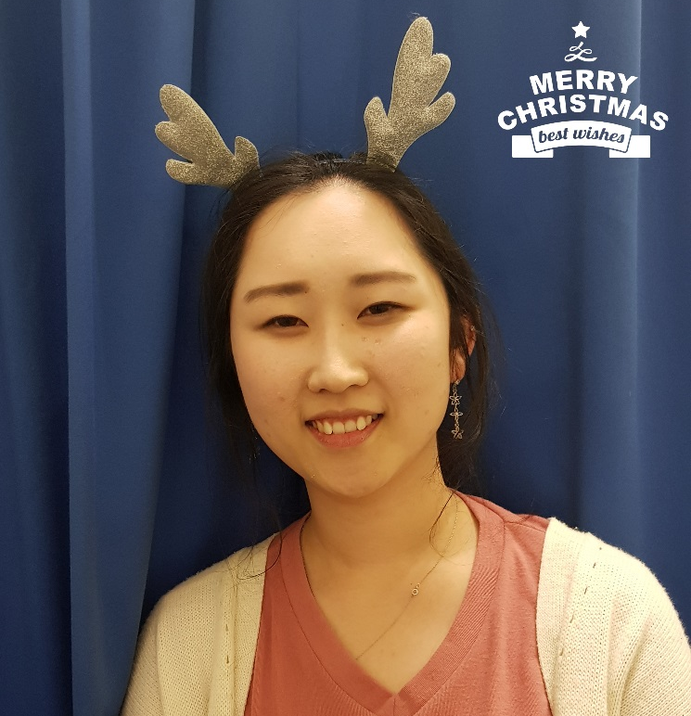
W E L C O M E T O D R E V Y S H I N
Evy is our new Registrar from the University of Auckland, she will be working with us for the next 6 months.
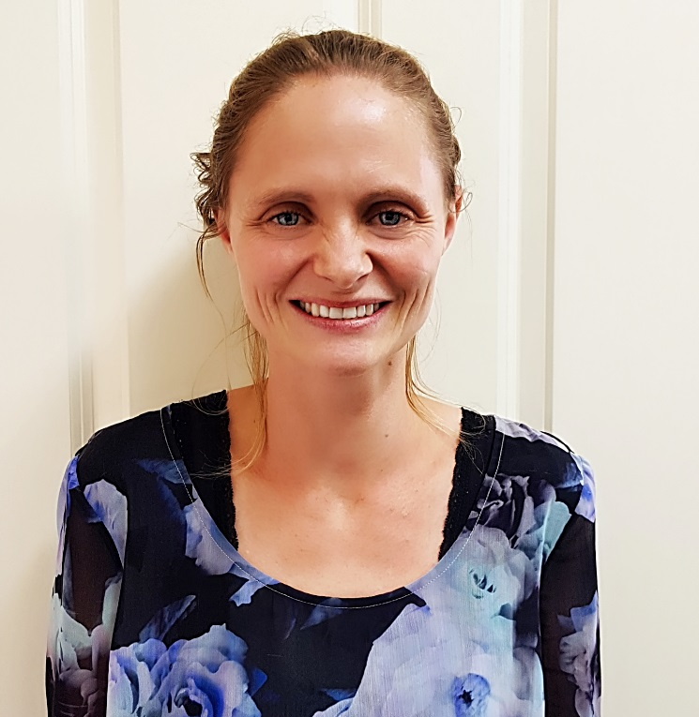
We have a new fourth year registrar working with us for the next 6 months Dr Shin

Sadly, we have said farewell to Dr Beth Mc Ewan-Walsh, who has been with us since 2016. Family commitments have taken her back to her old stomping ground in Matata. It has been great having Beth as part of our team and we wish her all the best.

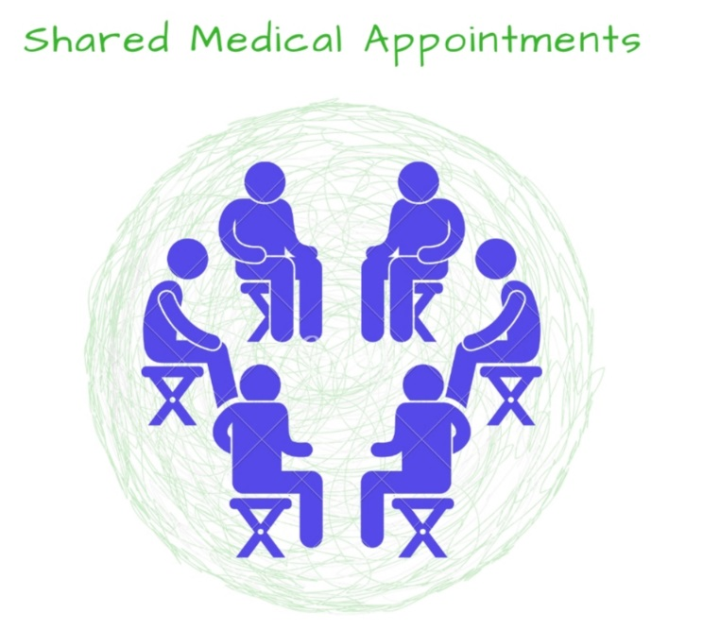
Health Te Aroha are beginning the process of implementing shared medical appointments (SMA) for some of our patients. The idea with a SMA is to get a group of patients together, who share a condition like diabetes or COPD and spend 60-90 minutes amongst the group.
Physical examinations are done privately in a separate room; the doctor then engages in a one on one fashion with other patients present, patients can support, encourage and bounce ideas off each other.
With chronic conditions sometimes 15 minutes (standard appointment time) is not long enough, just by listening to the other consultations in the group, patients can better understand their own condition, medications and health plan, or learn something they had not thought of or explored before.
By spending more time in a consult, the patient will develop a better relationship with the doctor and have increased support from the group. Privacy considerations have been made. All attendees and staff formally sign confidentiality paperwork.
While a relatively new concept in New Zealand, SMAs have been used successfully in the US for over 20 years.
M A N A G E M Y H E A L T H
Save time and take care of your health needs online. When you sign up for manage my health, you have access to a range of services:
View your medical records
Book Appointments with your doctor or nurse
Send secure electronic messages to your doctor
Manage your health goals and track your progress
View lab results
Update some of your personal information
Receive recall and appointment reminders – all managed in a health calendar
Request repeat prescriptions
Registering for Manage My Health is simple; just ask reception to sign up.
- You will need to provide a personal email address and proof of identity.
- You must be 18 years old or over.
- We will provide you with an activation code and instructions on how to complete your registration online.
- We will be on hand for any hiccups or if you need help, setting up.

