Health Te Aroha Newsletter
To provide GP led primary health care services in a multidisciplinary setting with a commitment to excellence

byuo

We have been inundated with enquires regarding MMR immunity and vaccination histories for our patients. We are working through this, please leave us a request if you would like us to check your records.
Ministry of Health have set guidelines for our practise to adhere to in regards to the distribution of vaccines. Vaccine stock is significantly limited and prioritised to high risk areas, meaning we are being drip feed vaccines according to under 5 population; we currently cannot offer vaccines outside the scheduled childhood immunisation programme which is sets the first dose of MMR at 15 months and the second dose at 4 years of age.
Vaccines may become available for distribution in the future for older patients who have not received 2 recommended doses of the MMR vaccine, we have a running list of patients who would like to be contacted, but can’t give an ETA at the moment.
Guidelines are subject to change, we will be keeping our Facebook page up to date with any developments.
@healthtearoha

Health Te Aroha is excited to offer a new service – Pharmacogenomics. In the initial consultation a non-invasive cheek swab is collected and your details are registered with MyDNA. The swab is sent to a lab in Australia (within New Zealand there is currently no community or DHB based laboratory that can processes DNA for genomics. All cheek swab/DNA samples are sent to a certified Australian laboratory in Melbourne), there your DNA is analysed and sequenced, it is tested against commonly prescribed medications and a personalised report is sent back to the GP. You will be contacted to make an extended consultation. The report provides prescribing recommendations for your doctor, based on your individual results. People break down medications differently, Pharmacogenomics help you and your doctor to make more informed decisions about which medications may work best. Personalised reports have lifelong relevance and can help provide a blueprint for managing health and wellness. Your reports and genetic data are your property. Any results generated remain strictly confidential, no results will be shared with any third parties. There are options available, on top of the medication tests for diet, caffeine and exercise analyses, for an additional cost. The cost is $250 for medication analyses and $350 for medication and lifestyle analyses, this cost includes two Dr consultations. Currently Dr Hayley Scott is the only provider registered for this service at Health Te Aroha. For enquires see reception.
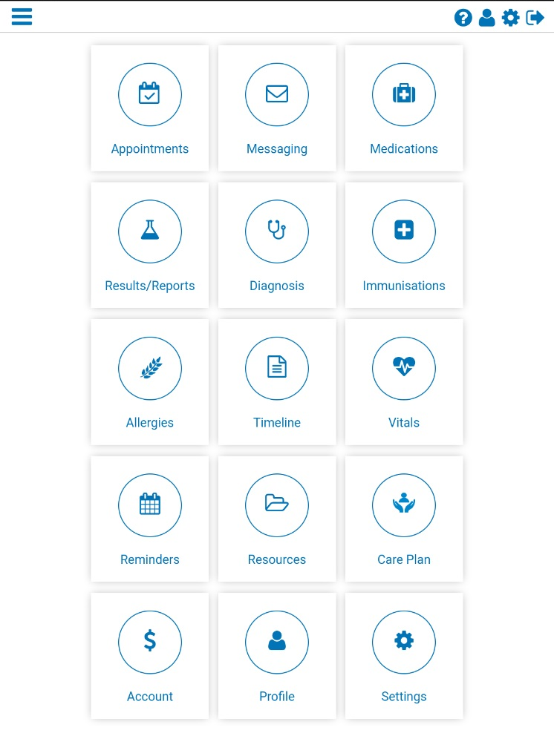
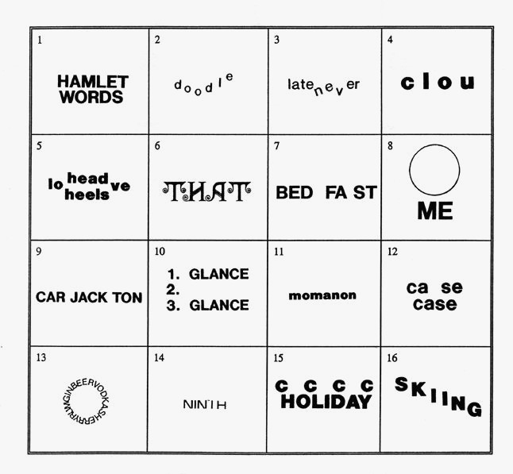
We at Health Te Aroha are holding Shared Medical Appointments (SMA). A SMA is a series of consecutive individual consults held in a supportive group setting so everyone can listen, interact and learn. Patients learn about chronic conditions vicariously by witnessing others illness experiences and in turn the providers learn from the patients how better to meet their patient’s needs. People in our practice tell us that it would be good to be connected with other people who are living with similar health conditions and are going through the same experiences. The SMA approach provides great support for patients; patient receive professional expertise from the doctor in combination with first-hand information from peers resulting in better health knowledge. Also patients have the opportunity to see how the doctor interacts with fellow patients which may allow them to get to know the doctor better, build rapport and trust. In addition they get to spend more time with the doctor- Hayley Scott (sometimes 15 minutes isn’t quite long enough to address all concerns regarding chronic conditions). Each session lasts around 60-90 minutes and comprises of around 6 patients and includes Dr Scott and a medical assistant, the cost is the same as a regular appointment, prescriptions and examinations are available like a regular consult, (examination can be done privately if the patient is uncomfortable doing this in a group, eg blood pressures) Confidentiality forms are provided and need to be read and signed before the consultation, so everyone is in agreement about privacy. The next SMA is scheduled for Friday the 11th of October and we are looking for patients with Diabetes Mellitus Type 2 who may be interested in attending. Enquire at reception.

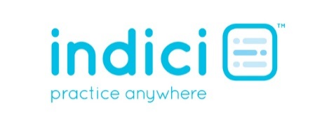

Our online patient portal “My Indici” is now free to sign up to. It takes two minutes to sign up and allows you access to your medical records, scripts requests, make appointments for yourself or your children, and much more. All we need from you is ID and an email address to send notification to. You do need to present to reception for initial sign up.
M I N D T E A S E R S

